# **Name: Abdurrahman Qureshi**

# **Roll No: 210451**

Practical No: 13

1. **Regular Expression to check for Birthday**

**CODE:**

Imports System.Text.RegularExpressions

Public Class Form1

Private Sub Form1_Load(sender As Object, e As EventArgs) Handles MyBase.Load

Me.BackColor = Color.FromArgb(25, 25, 25)

Me.ForeColor = Color.GhostWhite

Button1.ForeColor = Color.FromArgb(25, 25, 25)

End Sub

Sub Main()

Dim birthdayRegex As New Regex("^(0[1-9]|1[0-2])\/(0[1-9]|[12][0-9]|3[01])\/\d{4}$")

Dim birthday As String = TextBox1.Text

If birthdayRegex.IsMatch(birthday) Then

MsgBox("Valid birthday")

Else

MsgBox("Invalid birthday - Birthday Format = (MM/DD/YYYY)")

End If

End Sub

Private Sub Button1_Click(sender As Object, e As EventArgs) Handles Button1.Click

Main()

End Sub

End Class

**OUTPUT:**

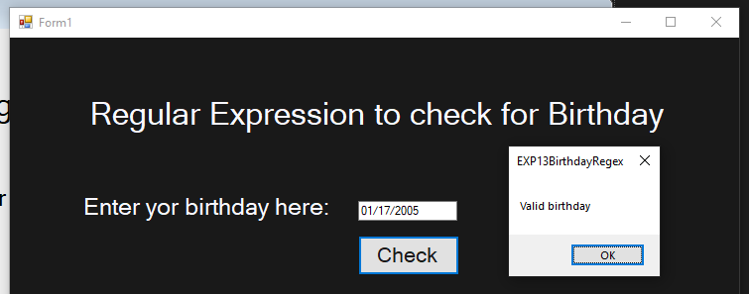

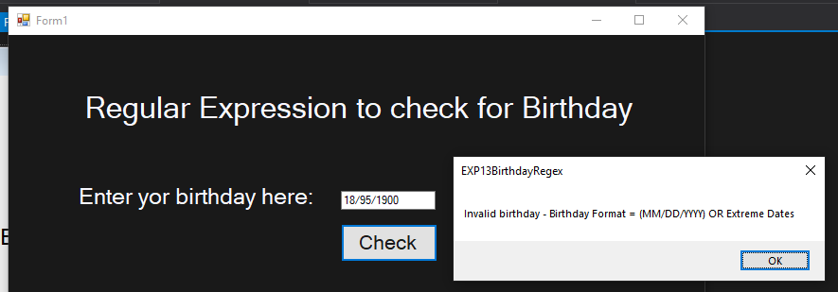

1. **Regular Expression to check for Email ID**

**CODE:**

Imports System.Text.RegularExpressions

Public Class Form1

Sub checking()

Dim input As String = TextBox1.Text

Dim emailPattern As String = ("^[a-zA-Z0-9._%+-]+@[a-zA-Z0-9.-]+\.[a-zA-Z]{2,}$")

Dim regex As New Regex(emailPattern)

If regex.IsMatch(input) Then

MsgBox("Valid email address")

Else

MsgBox("Invalid email address")

End If

End Sub

Private Sub Form1_Load(sender As Object, e As EventArgs) Handles MyBase.Load

Me.BackColor = Color.FromArgb(25, 25, 25)

Me.ForeColor = Color.GhostWhite

Button1.ForeColor = Color.FromArgb(25, 25, 25)

End Sub

Private Sub Button1_Click(sender As Object, e As EventArgs) Handles Button1.Click

checking()

End Sub

End Class

**OUTPUT:**

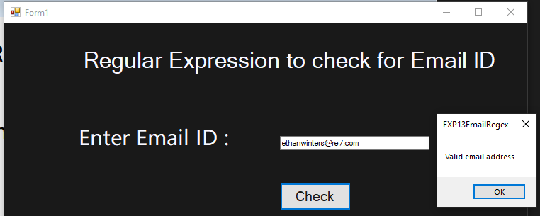

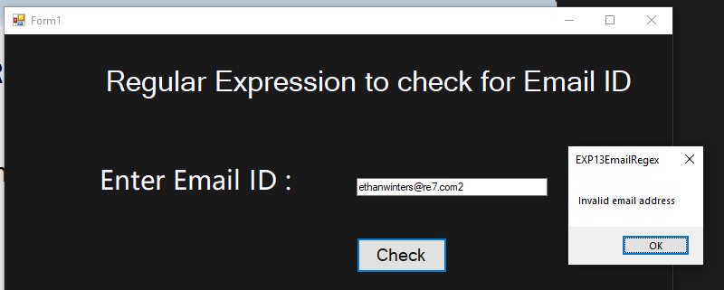

1. **Regular Expression to check for Name and Phone No.**

**CODE:**

Public Class Form1

Private Sub Form1_Load(sender As Object, e As EventArgs) Handles MyBase.Load

Me.BackColor = Color.FromArgb(30, 30, 30)

Label1.ForeColor = Color.GhostWhite

Label2.ForeColor = Color.GhostWhite

End Sub

Private Sub TextBox1_Validating(sender As Object, e As System.ComponentModel.CancelEventArgs) Handles TextBox1.Validating

If TextBox1.Text = "" Then

ErrorProvider1.SetError(TextBox1, "Empty")

Button1.Enabled = False

e.Cancel = True

ElseIf IsNumeric(TextBox1.Text) Then

ErrorProvider1.SetError(TextBox1, "No numerical value allowed")

Button1.Enabled = False

e.Cancel = True

Else

ErrorProvider1.SetError(TextBox2, "")

Button1.Enabled = True

End If

End Sub

Private Sub TextBox2_Validating(sender As Object, e As System.ComponentModel.CancelEventArgs) Handles TextBox2.Validating

If TextBox2.Text = "" Then

ErrorProvider1.SetError(TextBox2, "Empty")

Button1.Enabled = False

e.Cancel = True

ElseIf Not IsNumeric(TextBox2.Text) Then

ErrorProvider1.SetError(TextBox2, "No alphabetical value allowed")

Button1.Enabled = False

e.Cancel = True

ElseIf TextBox2.Text.Length <> 10 Then

ErrorProvider1.SetError(TextBox2, "Phone number should contain 10 digits")

Button1.Enabled = False

e.Cancel = True

Else

ErrorProvider1.SetError(TextBox2, "")

Button1.Enabled = True

End If

End Sub

Private Sub Button1_Click(sender As Object, e As EventArgs) Handles Button1.Click

MsgBox("Form Submitted")

End Sub

End Class

**OUTPUT:**

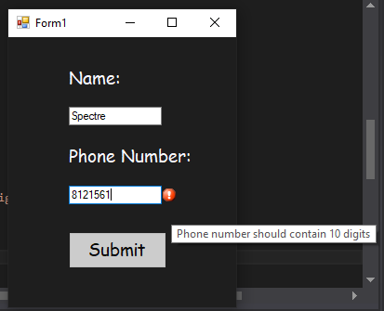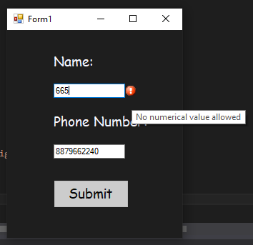

1. **Regular Expression to check for IP address**

**CODE:**

Imports System.Text.RegularExpressions

Public Class Form1

Sub Main()

Dim input As String = TextBox1.Text

Dim pattern As String = "^((0|1?\d{1,2}|2([0-4]\d|5[0-5])).(0|1?\d{1,2}|2([0-4]\d|5[0-5])).(0|1?\d{1,2}|2([0-4]\d|5[0-5])).(0|1?\d{1,2}|2([0-4]\d|5[0-5])))$"

Dim regex As New Regex(pattern)

If regex.IsMatch(input) Then

MsgBox("Valid input.")

Else

MsgBox("Invalid input.")

End If

End Sub

Private Sub Button1_Click(sender As Object, e As EventArgs) Handles Button1.Click

Main()

End Sub

Private Sub Form1_Load(sender As Object, e As EventArgs) Handles MyBase.Load

Me.BackColor = Color.FromArgb(30, 30, 30)

Me.ForeColor = Color.GhostWhite

Button1.ForeColor = Color.FromArgb(30, 30, 30)

End Sub

End Clas

**OUTPUT:** 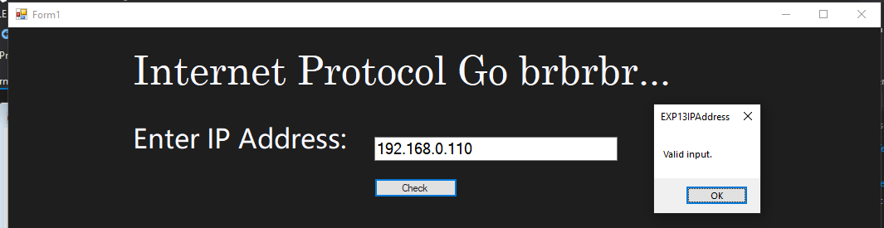

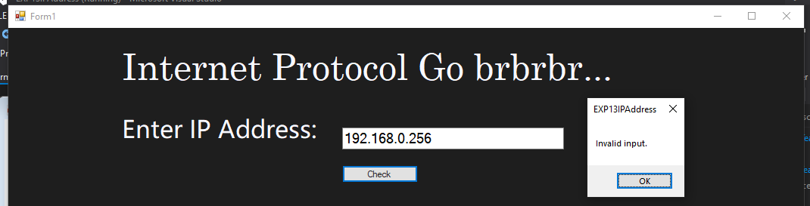

1. **Regular Expression to check for Range from 0 - 255**

**CODE:**

Imports System.Text.RegularExpressions

Public Class Form1

Sub Main()

Dim input As String = RangeTxtB.Text

Dim pattern As String = "^(0|1?\d{1,2}|2([0-4]\d|5[0-5]))$"

Dim regex As New Regex(pattern)

If regex.IsMatch(input) Then

MsgBox("Valid input.")

Else

MsgBox("Invalid input.")

End If

End Sub

Private Sub Button1_Click(sender As Object, e As EventArgs) Handles Button1.Click

Main()

End Sub

Private Sub Form1_Load(sender As Object, e As EventArgs) Handles MyBase.Load

Me.BackColor = Color.FromArgb(30, 30, 30)

Me.ForeColor = Color.GhostWhite

Button1.ForeColor = Color.FromArgb(30, 30, 30)

End Sub

End Class

**OUTPUT:**

